# RRU Forum Draft Posts

Contents

RRU Forum Draft Posts 1

Overview 2

Notable Behaviors 2

Installation 2

Testing 3

Test cases setup 3

Test cases 3

Algorithms / Code Changes 4

Database changes 4

Code Changes 4

## Overview

This customization allows users to (manually and automatically) save drafts of their forum discussions and posts that can be retrieved and modified at a later date.

### Notable Behaviors

The forum screen now contains a “Save draft” button below the “Attachments” section to manually save a copy of the subject and message of the post. Drafts can be restored via two methods: visiting a discussion/post that has an existing draft will display a dialog box asking if the user wishes to restore the draft; visiting the Discussion drafts (draftposts.php) screen accessible from the forum screen or the discussion screen allows the user to restore the draft. A draft can be manually deleted through the Discussion drafts (draftposts.php) screen if it is no longer needed. When a discussion or reply post is saved, the draft of this discussion/reply post is automatically deleted.

#### Users

* All users will see:
  + a “Save draft” button on the edit discussion/post screen
  + a “Draft discussions” link on the view forums and view discussions screen that takes the user to a list of their new discussions and/or reply drafts for either forums or discussions. They can only see drafts they have created.
  + an extra column on the forum table (mod/local/forum/index.php) that displays the number of drafts for each forum

#### Administrators

* Administrators will see the same as all other users, but will be able to see drafts created by all users

## Installation

1. Navigate to the *local* folder in the Moodle structure
   1. cd /var/web/wwwroot/moodle/local
2. Export the installation package from SVN
   1. svn export –force svn+ssh://yoursvnuser@whiskey/var/lib/svn/moodle/Moodle/2.1/INSTALLS/draftposts/rru_draftposts-***version***.tgz
3. Run the patch to add necessary changes to forum module files from the local/draftposts folder
   1. cd draftposts
   2. patch –p0 --dry-run < draftposts_forum-***version***.patch (test out patch)
   3. patch –p0 < draftposts_forum-***version***.patch (apply the patch)
4. Clean up the install files
   1. rm draftposts_forum-***version***.patch
   2. rm ../rru_draftposts-***version***.tgz
5. Log onto the Moodle instance with an admin account and press the “Upgrade” button when the “Plugins check” screen appears
   1. You should see “local_draftposts” Success followed by a “Continue” button – click it
   2. You should see “New settings - RRU Draft Posts”
      1. The “Save interval” defaults to 180 seconds, but can be overridden.
      2. Click “Save changes” to continue

## Testing

### Test cases setup

Create a new course with at least one instructor and multiple students with a sample of each of the different types of forums. These are the typical course scenarios that need to be accounted for:

1. **Single section** with any combination of groups (ie. teams, dyads, triads)
   1. Could have multiple instructors
   2. Typically will have a maximum of XX students (not large enough to split into multiple sections)
2. **Multiple sections** with any combination of groups (ie. teams, dyads, triads)
   1. Will definitely have multiple instructors
   2. Has more than XX students and needs to be split into multiple sections
   3. Uses ‘groupings’ to separate the sections
   4. **Scenario 1** – instructors do not see each other’s sections
   5. **Scenario 2** – instructors ‘team teach’ and do see each other’s sections
   6. **Scenario 3** – instructor A is a moderator and sees all sections. Instructor B sees only their own section.

When using any type of ‘groups’ or ‘groupings’, current Moodle functionality restricts forum discussion topics to groups. From the Moodle docs <http://docs.moodle.org/20/en/Groups_FAQ#What_is_the_.27force.27_setting.3F>

**As a teacher I want to put the same post in each group's forum with students able to reply to that post. How can I do this?**

*You need to post the same message into the forum for each group. There is currently no way to do this in one go if you want students to be able to reply to your post. If you don't mind students not being able to reply, then you can of course just post the message to all participants.*

Use the test courses provided which have all of the above parameters already in place. You can restore them to your test platform.

Sharepoint site:

Moodle working folder:

\\abersan-2\Communities\Staff\academic and information services\it-services\private\Moodle 2.0 Upgrade project\Testing\Test Courses\Moodle 212

### Test cases

List the various different ways this customization needs to be tested providing step-by-step instructions.

### Log in as an instructor

#### Save a draft for a new discussion

1. Browse to the ‘**Team forum**’ and add a new discussion topic
2. Enter a subject and a message
3. Click the “Save draft” button
4. Navigate back to the main forum page by clicking the left navigation or breadcrumb

#### Restore a draft for a new discussion

There are three ways to restore a draft.

* Clicking on the ‘Add new discussion’ button in the forum you saved the draft in
* Clicking on ‘Draft discussions’ then clicking on ‘Restore’
* Clicking on ‘Draft discussions’ then clicking on the name of the draft post

1. 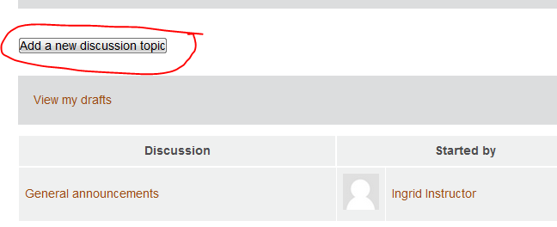Click on the ‘**Add a new discussion**’ button
2. You should be prompted with a pop up box to restore your draft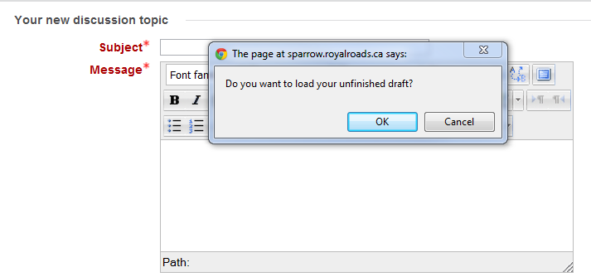
3. Click ‘OK’ and then the ‘Post to forum’ button.

#### Restore a draft from Discussion drafts form (draftposts.php)

1. From the main forum page, click on the ‘View my drafts’ link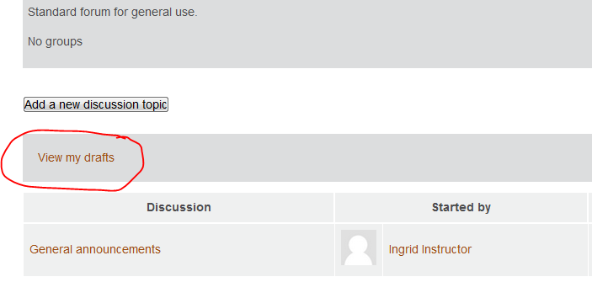
2. Find the draft post and click on the ‘**Restore**’ link or on the draft post title
3. 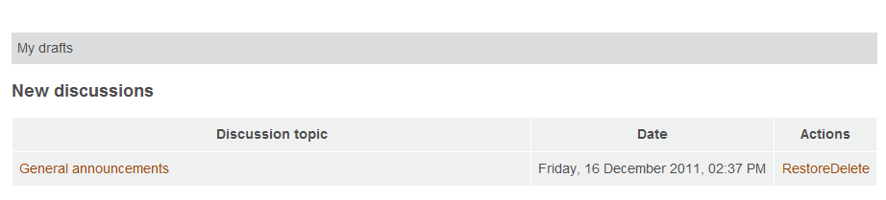You will be prompted to restore your post
4. Click on the ‘Post to forum’ button to post the draft to the forum.

#### Delete a draft from Discussion drafts form (draftposts.php)

1. From the main forum page, click on the ‘View my drafts’ link
2. Click on the draft post
3. Click on the ‘Delete’ link under Actions
4. Follow the prompts to confirm the deletion.

### Log in as a student

Test replying to topics the instructor has posted and posting your own topics saving drafts along the way.

#### Save a draft for a reply post

1. Select a forum to reply to
2. Click on the forum topic
3. Click on ‘Reply’
4. Write your post
5. Click ‘Save Draft’
6. Navigate back to the forum topic
7. Click on ‘Reply’ one more time
8. You should be prompted to restore your draft
9. Click ‘Ok’ and then ‘Post to forum’

#### Save a draft while editing an existing discussion

1. Edit an existing reply to a forum discussion topic.
2. You should only be able to edit your own replies.
3. Add some text to the reply.
4. Click on ‘Save draft’
5. Navigate back to the forum topic
6. Edit your reply one more time
7. You should be prompted to restore your draft post.
8. Select ‘Ok’ and then ‘Save Changes’
9. Your post should contain the new text you added.

#### Save a draft for a new discussion

1. Go to a forum
2. Click ‘Add a new discussion topic’
3. Add a new topic and description
4. Click ‘Save draft’
5. Navigate back to the forum
6. Select ‘View My Drafts’
7. Select the draft title
8. You should be prompted to restore your draft
9. Click ‘Ok’ and then ‘Post to forum’

#### Save a draft for a new discussion by waiting the for the draft save interval to pass (3min)

1. Go to a forum
2. Click ‘Add a new discussion topic’
3. Add a new topic and description
4. Wait 3 min to see if the draft saves automatically
5. Test restoring the draft.

## Algorithms / Code Changes

### Database changes

Moodle.mdl_rrudraft_forum_posts – stores the drafts

### Code Changes

Although every effort was made to create an autonomous plugin, some files in the forum module (mod/forum) had to be modified since the draft posts plugin is tightly coupled with the forums.

Draftposts plugin files are stored in the /local/draftposts folder

* /db/install.xml – xml table definition for database objects
* /lang/en/local_draftposts.php – language strings specific to draftposts plugin
* ajax_draftposts.php – AJAX destination file – handles database gets and saves
* draftposts.php – allows user to see and action their drafts for the forum/discussion
* lib.php – draftpost specific functions
* module.js – the Javascript script for draftposts (NOTE: must be called module.js)
* settings.php – handles draftposts plugin settings (like Save interval)
* version.php – Moodle version management file

Forum module changes - /mod/forum folder

* index.php
  + Modified to include a “Drafts” column in the table showing the number of existing drafts for the forum. Applies to both the general and learning forums
* lib.php
  + Added hooks (dp_print_drafts_link()) to display the link to draftposts.php (allow user to view drafts)
    - forum_print_latest_discussions() - 2 instances
    - forum_print_discussion() – 1 instance
* post.php
  + Added hooks (dp_delete_draft()) to delete drafts when posts are saved or deleted
    - 3 instances
  + Added code to hook in Javascript and store some session variables for use in the module.js file
* post_form.php
  + Added hook to display Save Draft button - dp_return_save_draft_button()

#### Settings

Under the Site administration -> Plugins -> Local plugins -> RRU Draft Posts

**Save interval** (local_draftposts|saveinterval) – determines the number of seconds to wait between saving a draft post on the mod/forum/post.php page.

#### Patch files

* draftposts_forum-***version***.patch where version refers to the Moodle version (e.g. 2.1.0)